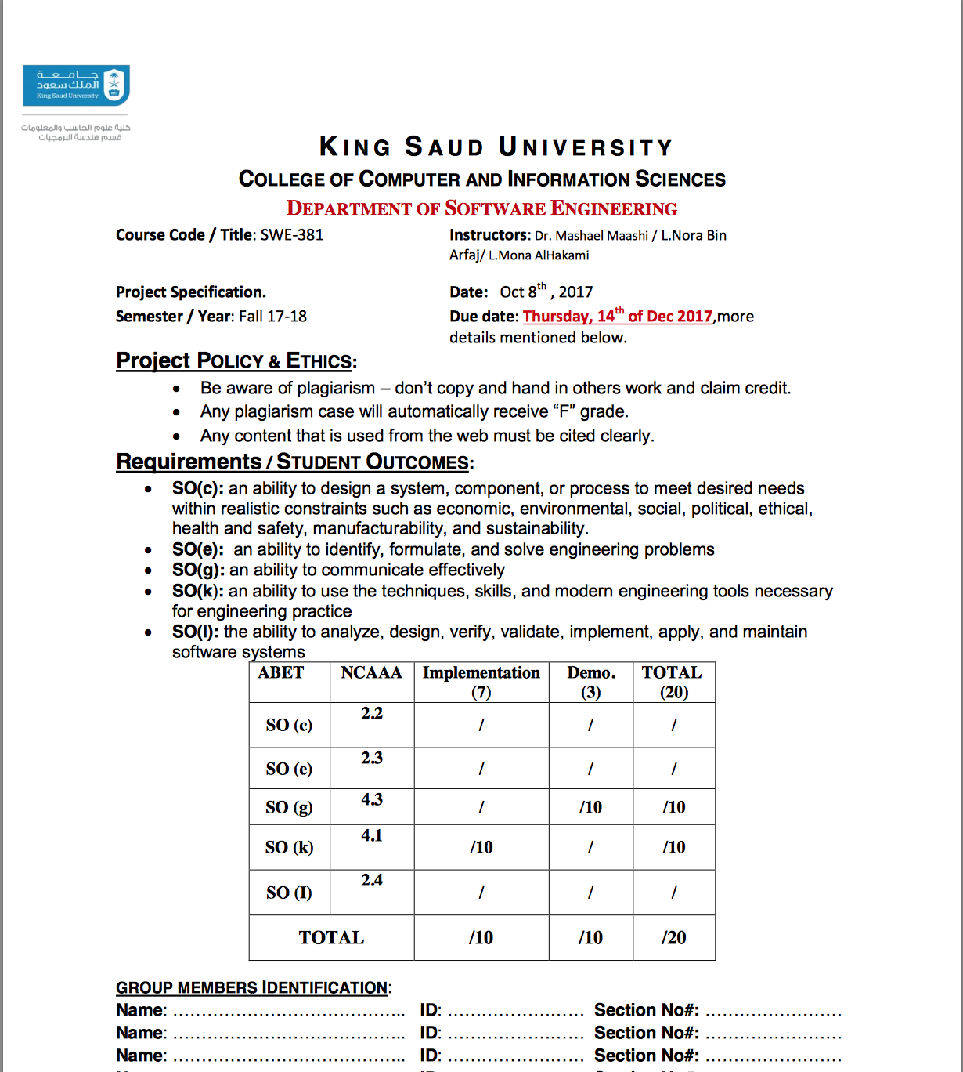

|  |  |  |
| --- | --- | --- |
| Student Name : | ID: | Work distribution: we all worked on this together as a team but here are some functions that were assigned to one of us in particular .: |
| Noura alsa’adan | 436202586 | Create a new book category.  Update the account information |
| Reema almuhanna | 436200927 | Search for a specific book  View report of existing books. |
| Maram alodan | 436200913 | Delete books.  Send notifications to members regarding the due date |

*Difficulties* :

1. When a student borrows a book it took us a bit of time to figure out how to add an option that allows them to extend the time.
2. Database was a bit difficult to work with , where the sequence of the pages was working but it wasn’t adding to the database. So we switched the parameters in the select database.